Table of Contents
Table of Contents 1
Cloud Watch 2
High-level steps 2
Assign an IAM Role to the EC2 Instance 2
Attach the IAM Role to the EC2 Instance 4
Install the CloudWatch Agent on the EC2 Instance 5
Verify Logs in CloudWatch 7
Install httpd and check the details in CloudWatch 8
Export logs from CloudWatch Logs to an S3 bucket 8
Create S3 Bucket 8
CloudWatch Logs Export 10
Verify Logs in S3 12

Cloud Watch
Amazon CloudWatch is a service that monitors applications, responds to performance changes, optimizes resource use, and provides insights into operational health. By collecting data across AWS resources, CloudWatch gives visibility into system-wide performance and allows users to set alarms, automatically react to changes, and gain a unified view of operational health.

To install the CloudWatch agent on an EC2 instance and configure it to send all logs to Amazon CloudWatch, follow these steps

High-level steps
- Assign an IAM Role to the EC2 Instance
- Install the CloudWatch Agent on the EC2 Instance
- Configure the CloudWatch Agent
- Verify Logs in CloudWatch

Assign an IAM Role to the EC2 Instance

Open the IAM Management Console, Click Roles → Create Role
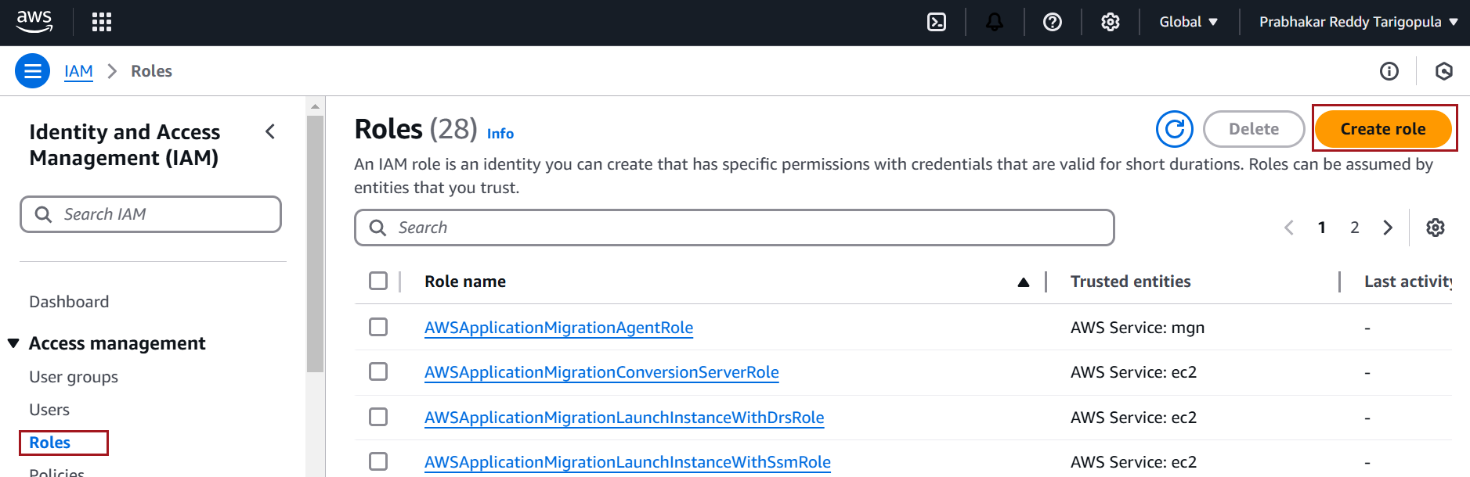

Select AWS Service → EC2 → Next
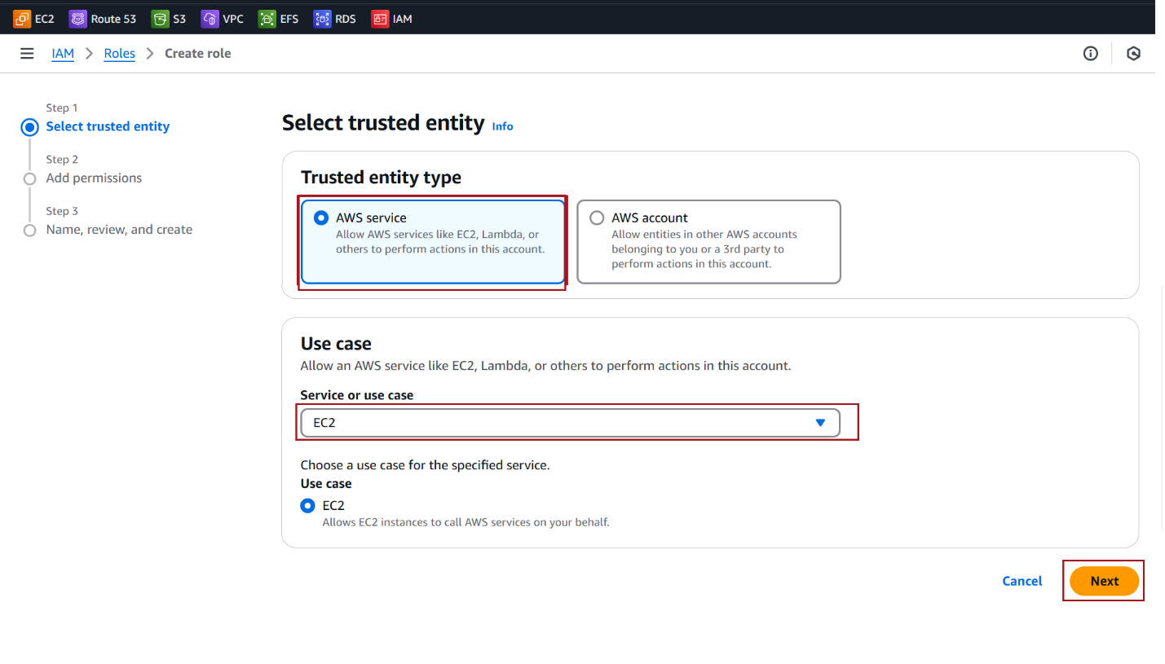
Attach the CloudWatchAgentServerPolicy managed policy
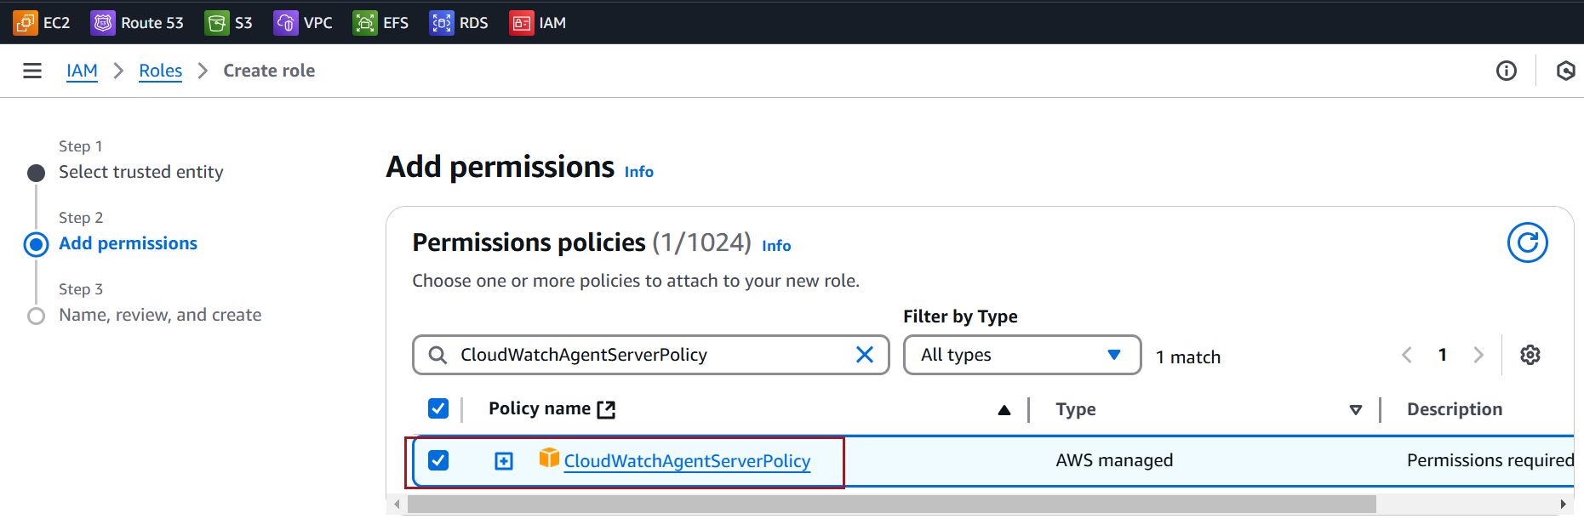

Provide a name for the role, e.g. customs-CloudWatchFullAccessRole, and create the role.
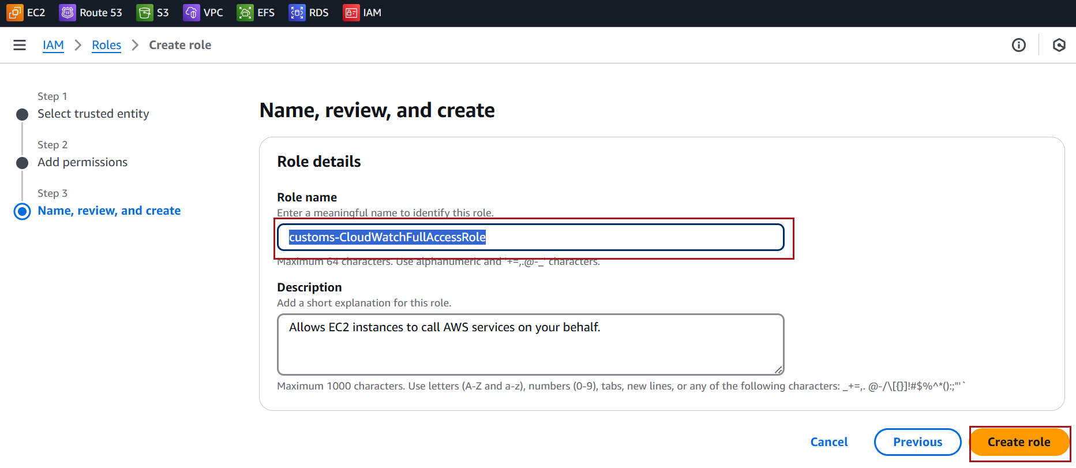

Attach the IAM Role to the EC2 Instance
Select the EC2 instance where you want to install the CloudWatch agent.
Click Actions → Security → Modify IAM Role.
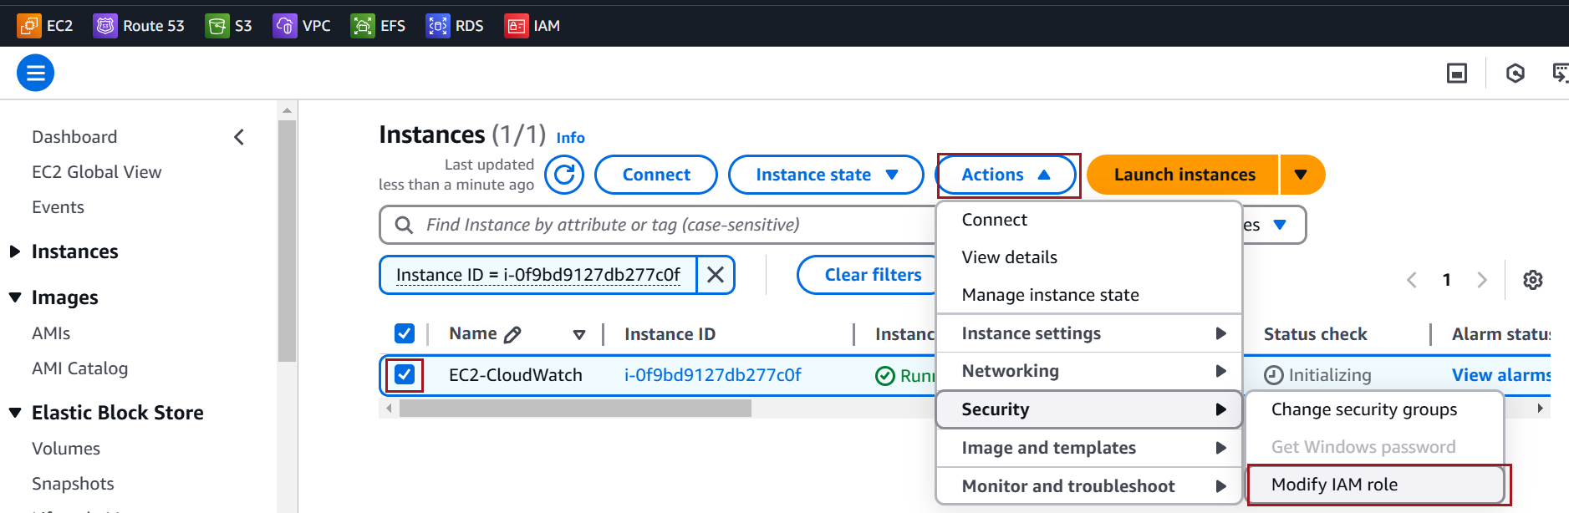

Select the IAM role you just created and click Update IAM Role
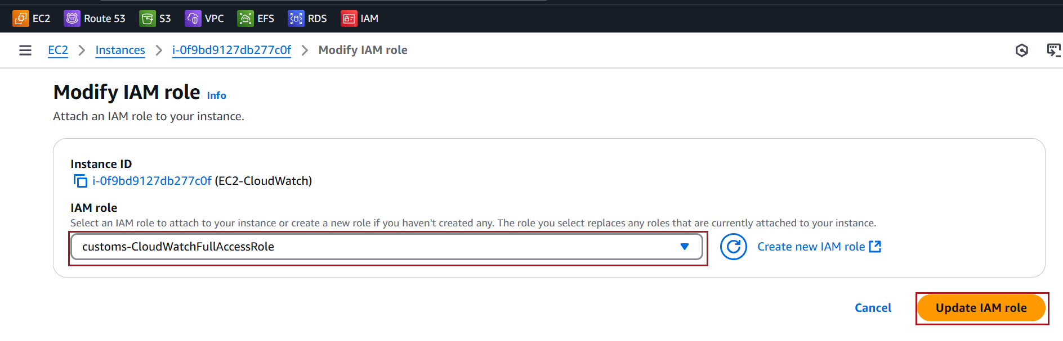

Install the CloudWatch Agent on the EC2 Instance
Connect to the EC2 Instance and run the command below to install couldwatch Agent
sudo yum install amazon-cloudwatch-agent -y
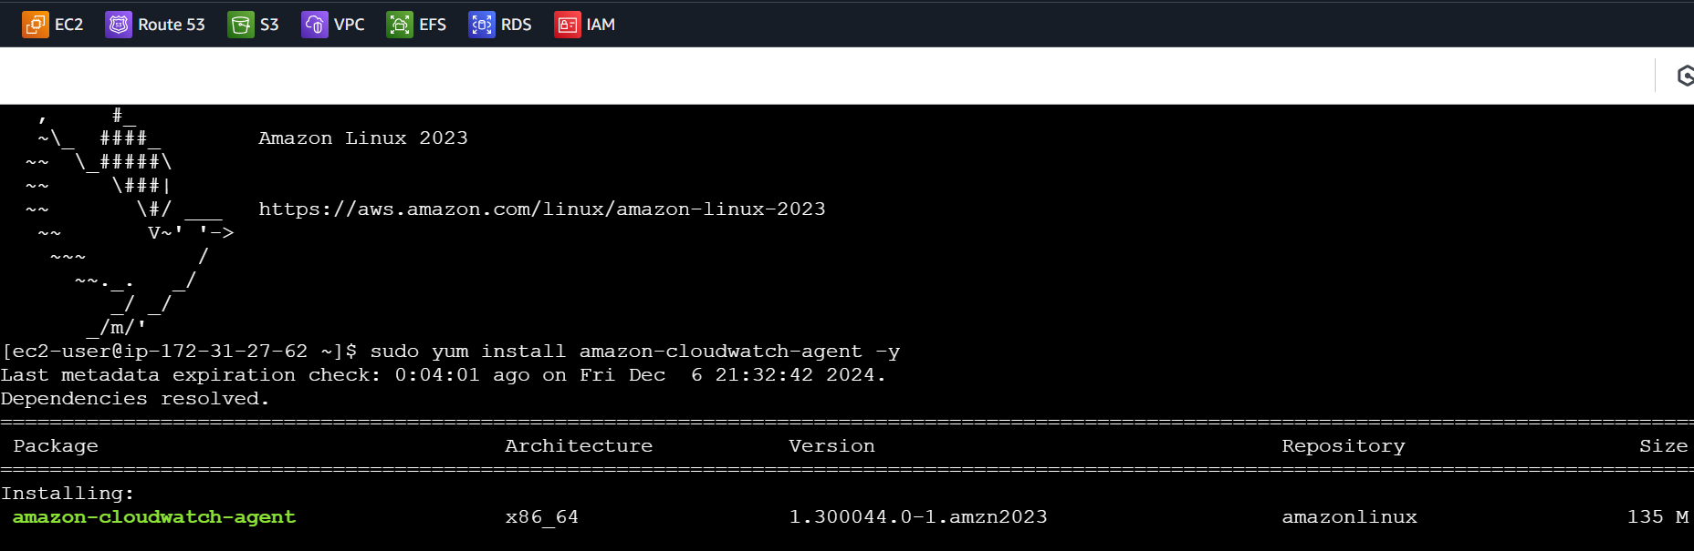
Create a Configuration File using below command
sudo vi /opt/aws/amazon-cloudwatch-agent/bin/config.json
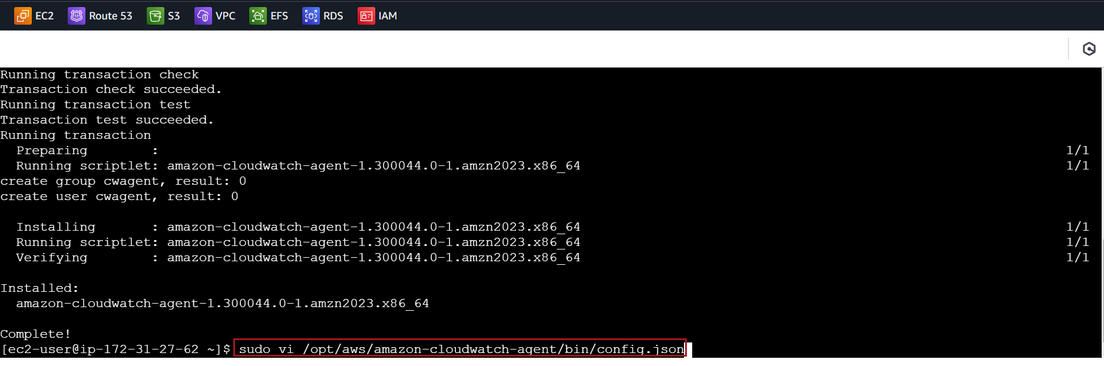
Add the following configuration to capture all logs

{
"logs": {
"logs_collected": {
"files": {
"collect_list": [
{
"file_path": "/var/log/*",
"log_group_name": "ec2-all-logs",
"log_stream_name": "{instance_id}-all-logs"
}
]
}
}
}
}

Start the agent using the configuration file:

sudo /opt/aws/amazon-cloudwatch-agent/bin/amazon-cloudwatch-agent-ctl -a fetch-config -m ec2 -c file:/opt/aws/amazon-cloudwatch-agent/bin/config.json -s

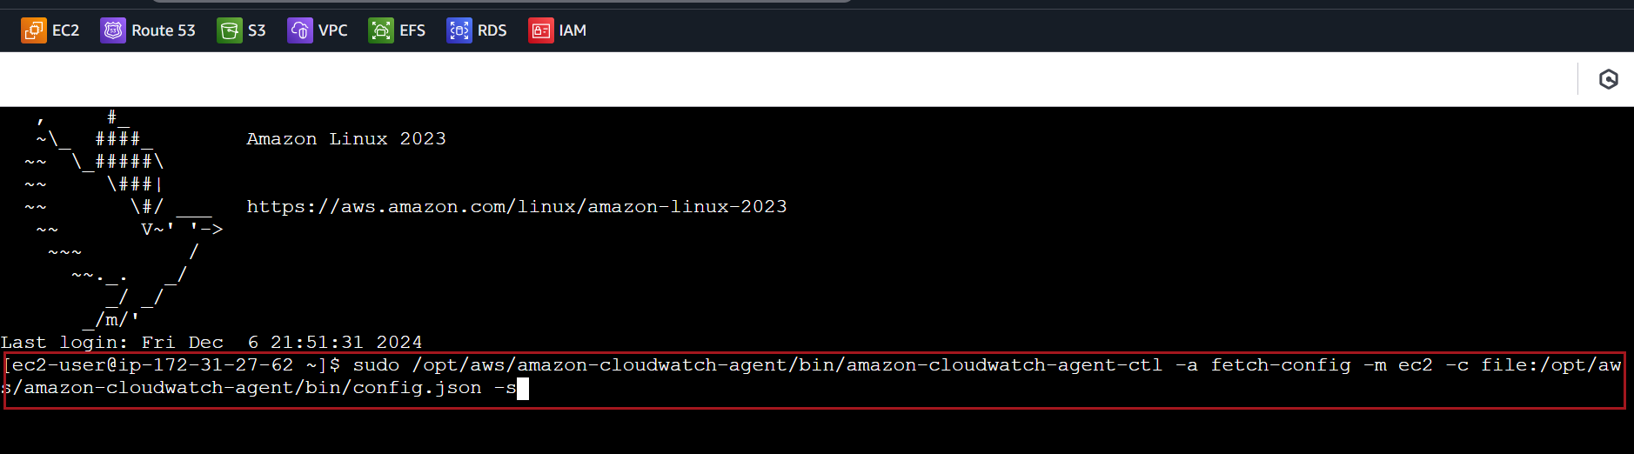

Logs typically appear in CloudWatch within 2 to 5 minutes of enabling the agent, depending on the configuration and volume of logs being generated

Verify Logs in CloudWatch
Open the CloudWatch Console in the AWS Management Console
Navigate to Logs → Log Groups
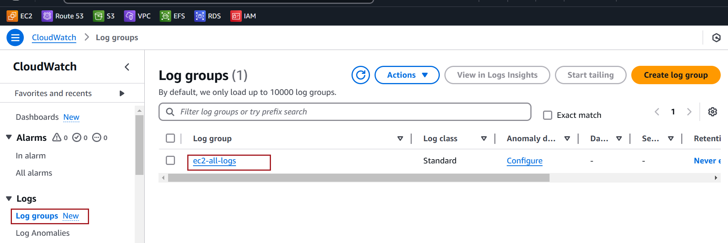

Select a log group and view log streams for your EC2 instance
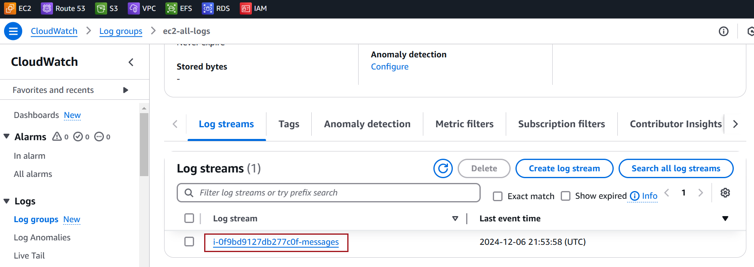

Install httpd and check the details in CloudWatch
sudo yum install httpd -y
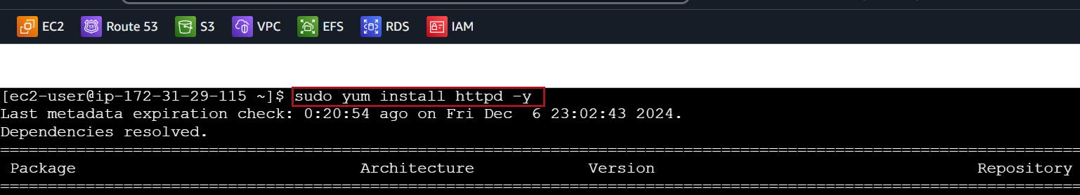

Verify the httpd log in cloudwatch
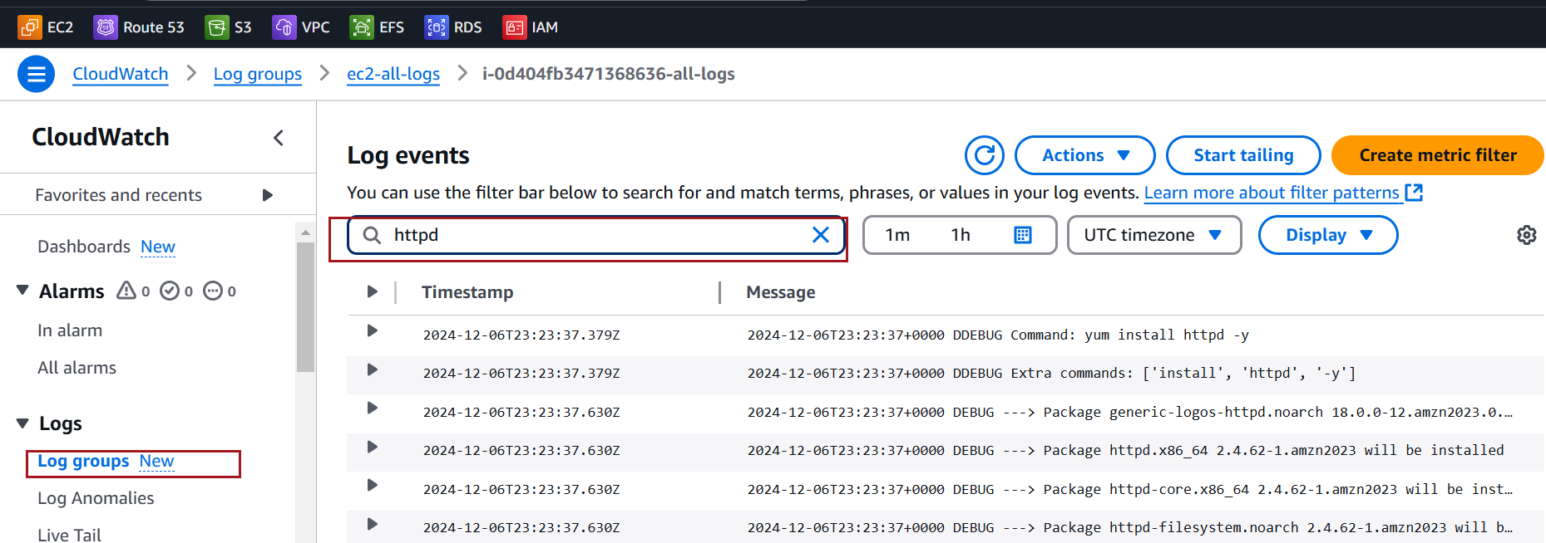

Export logs from CloudWatch Logs to an S3 bucket

Create S3 Bucket
Navigate to the S3 service
Click Create bucket after entering Bucket Name and leave other defaults
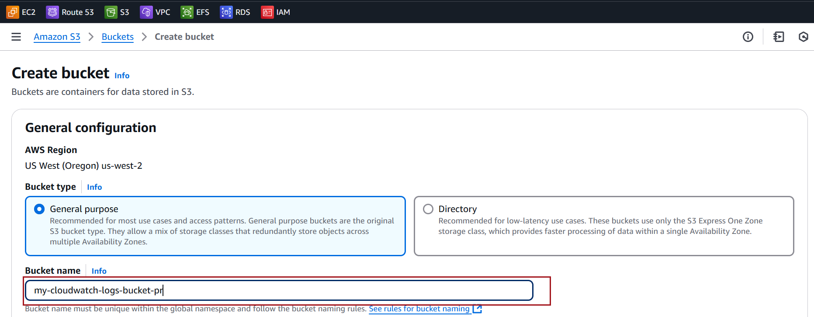
Go to the bucket's Permissions tab

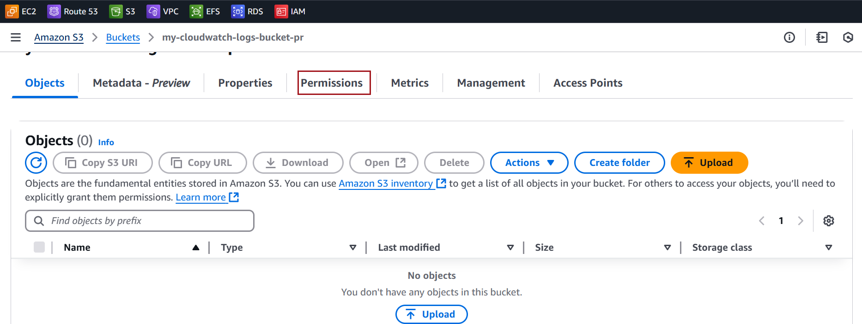

Go to Bucket Policy. Click Edit
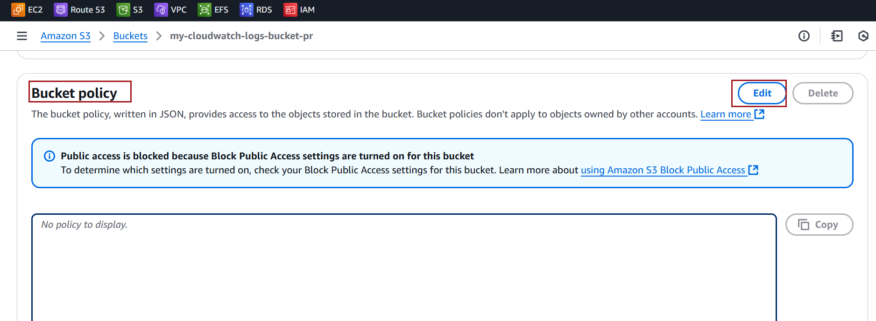

Add the following policy:

{
"Version": "2012-10-17",
"Statement": [
{
"Sid": "AllowCloudWatchLogs",
"Effect": "Allow",
"Principal": {
"Service": "logs.amazonaws.com"
},
"Action": [
"s3:PutObject",
"s3:GetBucketAcl",
"s3:GetObject"
],
"Resource": [
"arn:aws:s3:::my-cloudwatch-logs-bucket-pr/*",
"arn:aws:s3:::my-cloudwatch-logs-bucket-pr"
]
}
]
}

Click on Save Changes

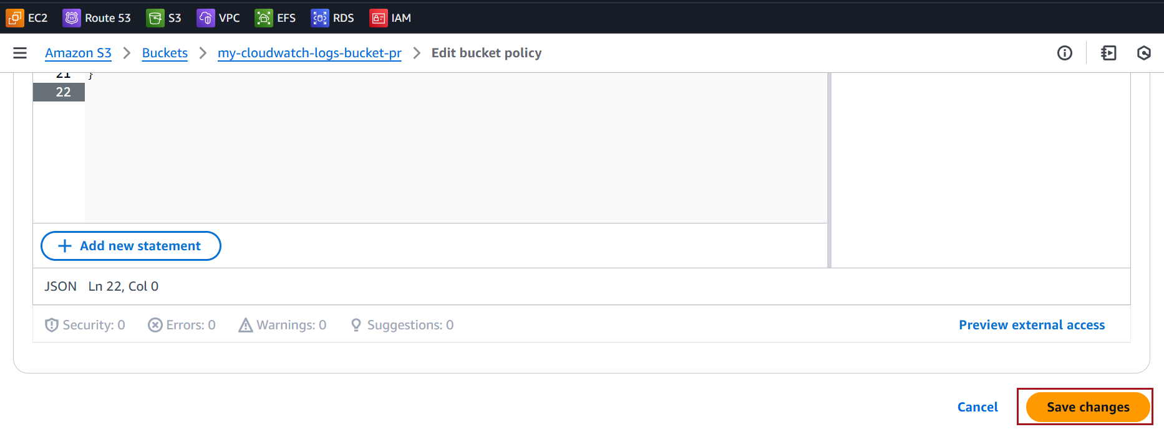

CloudWatch Logs Export
Navigate to Logs → Log Groups
Choose the log group you want to export
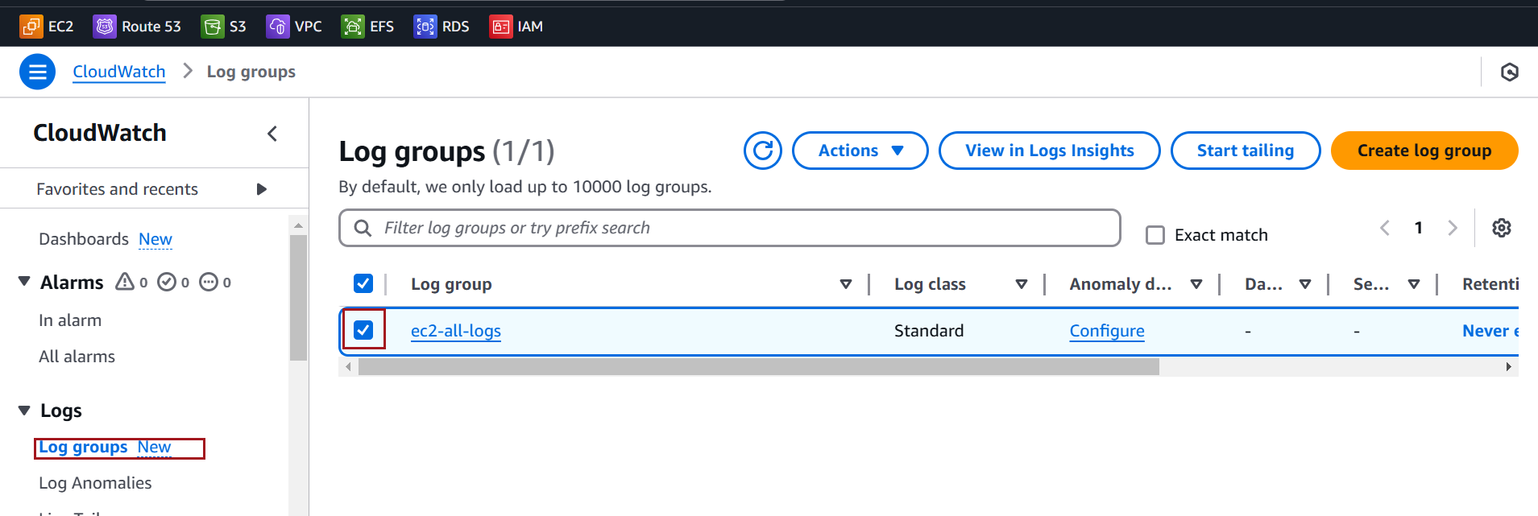

Click on Actions → Export data to Amazon S3
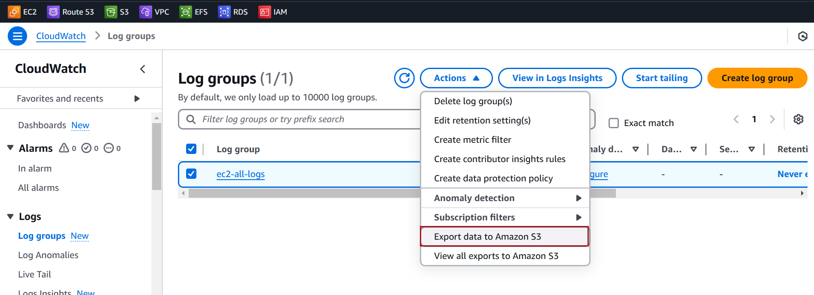

Choose your S3 bucket name and Click on Export
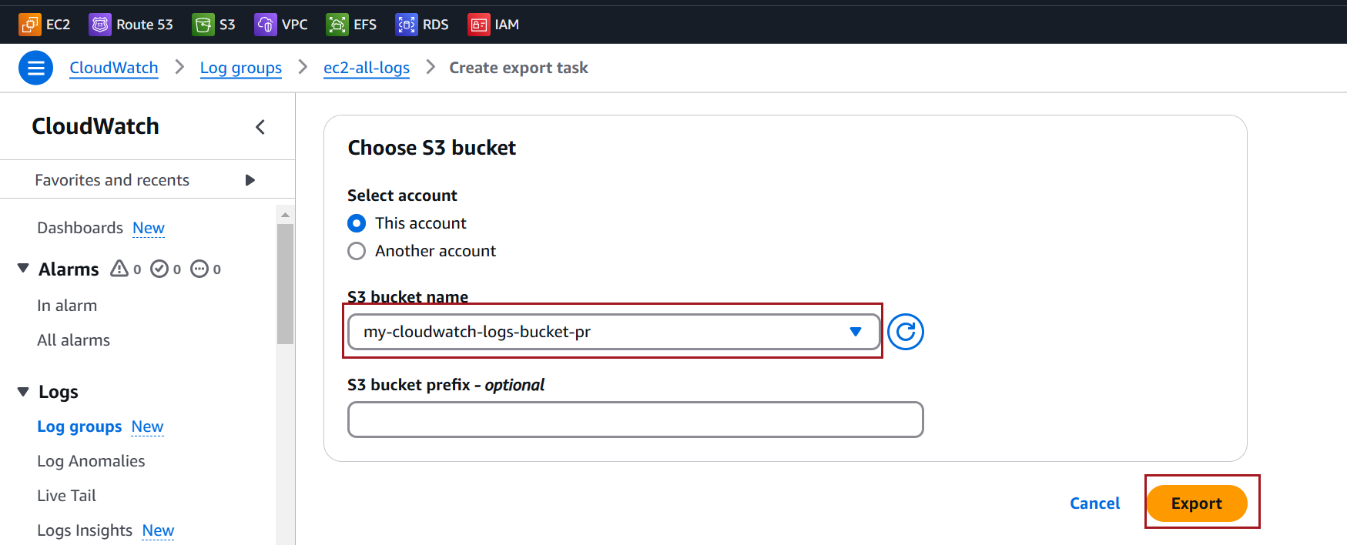

Verify Logs in S3
Open the bucket and check for logs in the specified folder or directly at the root
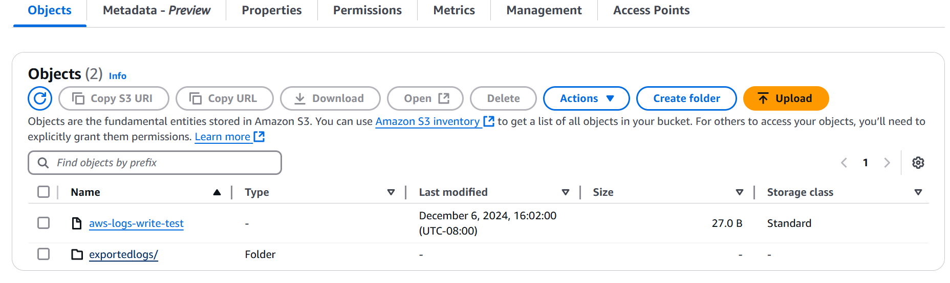

You should see files in .gz format, as CloudWatch compresses the exported logs.
